## **João Agostinho 57538**

### Code Smells

1. Dead Code

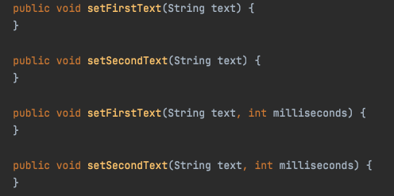

Location: ganttproject/build/classes/java/main/net/sourceforge/ganttproject/gui/GanttStatusBar.java

These methods are completely empty and have no use for the program.

Solution: Removing these methods.

1. Data Class

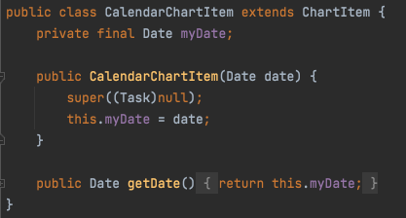

Location: ganttproject/build/classes/java/main/net/sourceforge/ganttproject/chart/item/CalendarChartItem.class

This class is only used to store a date and only has one method to return it.

Solution: Instead of a class, use an array to store this data.

1. Long Method



Location: ganttproject/build/classes/java/main/net/sourceforge/ganttproject/calendar/CalendarEditorPanel.class

This method is very extensive (more than 60 lines), making it hard to read and comprehend.

Solution: Creating private auxiliary methods to distribute its function.